**Export DICOM from Tomo to RayStation**

**Purpose:** This procedure explains how to export DICOM from Tomo Planning System, to a file.

1. We recommend creating a folder called *<last name>, <first name> <plan name>* in the **Exported Tomo Plans** folder on the Z drive, but you can of course export data to any writable folder.
2. Open the Delta4 folder on the desktop and double click to run the DICOMpiler.

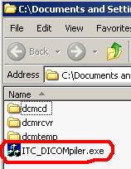

1. Click *OK*.

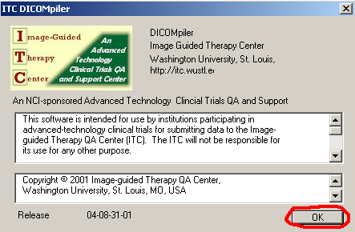

1. Enter the following values:
   1. Sponsor: patient last name
   2. Protocol: patient first name
   3. Case: patient MR#
   4. Initials: your initials
2. Click *Make Patient ID*.

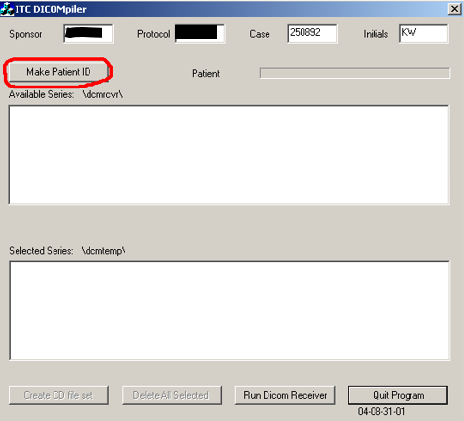

1. Click *Run DICOM Receiver*. The *ITC DICOM Receiver* dialog box will appear.

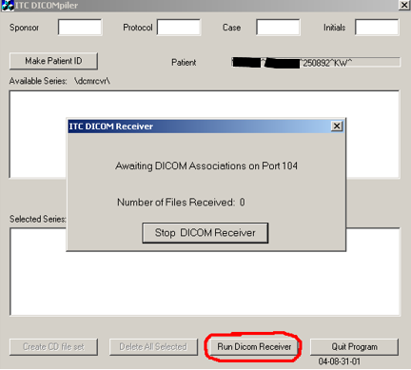

1. Open the Tomo Planning application on one of the Tomo computers. If a patient is open, clear them by clicking **Toolbox > Clear Selected Patient**.

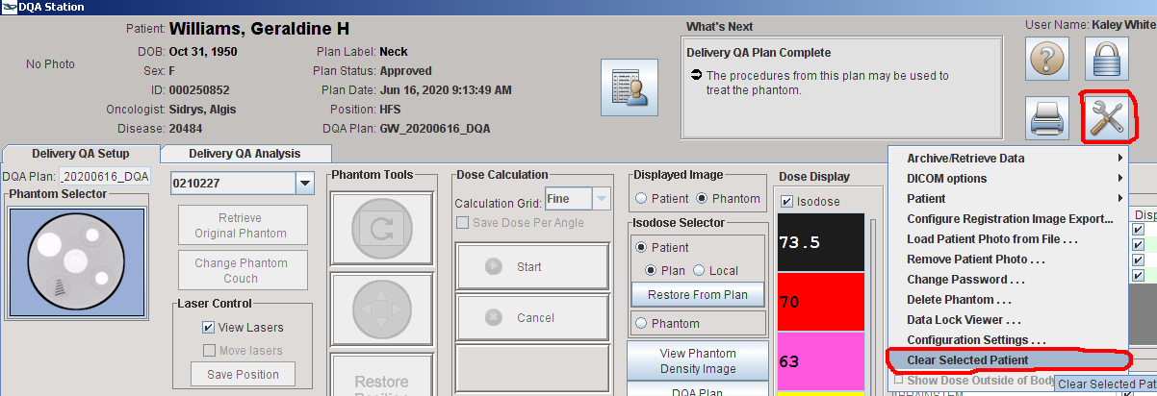

1. Go to **Toolbox > DICOM options > Export items…**

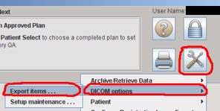

1. Use the **Patient Selector** to navigate to the plan you want to export. Select the plan as well as its associated image, optimized dose, and structure set.
2. If you are on Tomo computer #1, select **Delta4_Local** from the **<Select a destination>** dropdown. If you are on Tomo computer #2, select **Delta4_PS2 Local**.

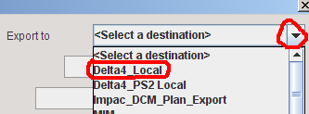

1. Click *Send Now*.

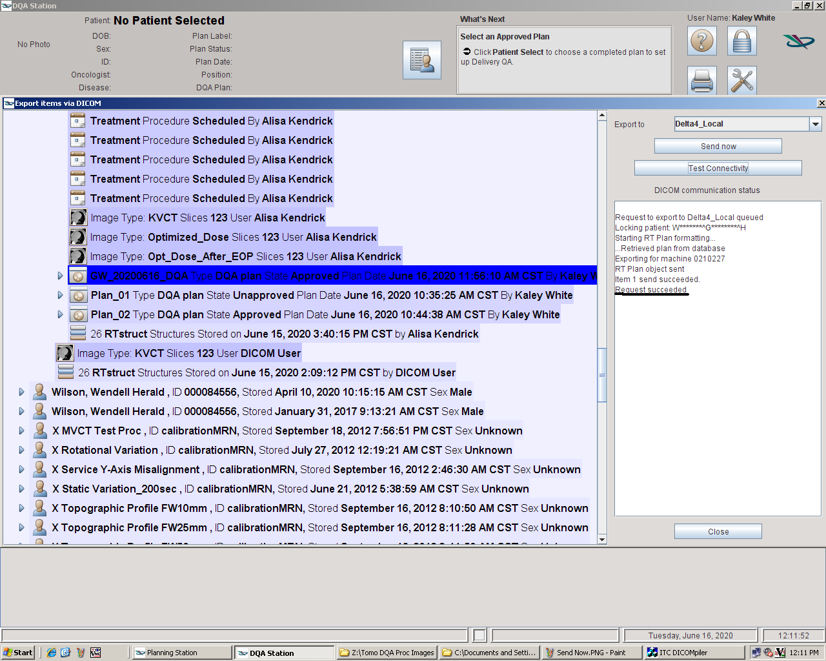

1. You should see the message **Request Succeeded** for each successfully exported file.
2. The DICOM receiver should have received four files. Stop the DICOM receiver.

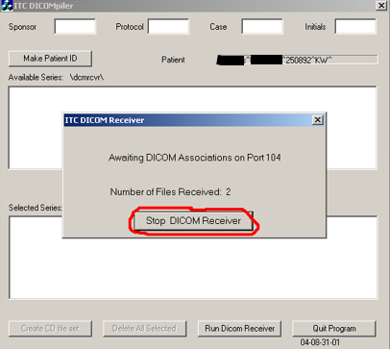

1. Move all files to the **dcmtemp** folder by clicking **Select All Series**.

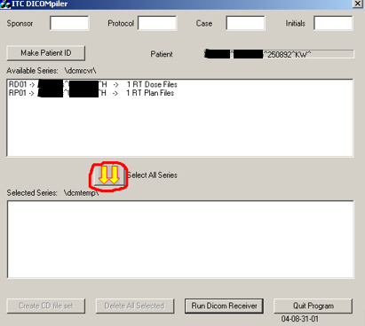

1. Move the files from **dcmtemp** to the folder created in step (1).
2. Delete all files from **dcmtemp** and close the DICOMpiler.

